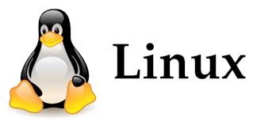

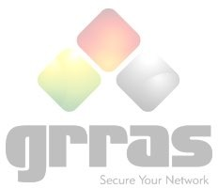**BASIC LINUX**

## Lecture 1.

* Introduction to Open Source
* Understanding of Operating System
* History and the future of Linux
* Why Linux is best in compare to Windows
* Uses of Linux in latest technologies
* RedHat Certifications
* Requirement of RedHat Certifications
* Introduction of Advanced Certifications

## Lecture2.

* Understanding of File system and File types in Linux
* Understanding of disk partitions, MBR and BIOS
* Boot Loader & Booting Process of Linux

## Lecture3.

* Installation of Operating System
* Understanding of installation process
* Installation By CD, Network or on Virtual Machine

## Lecture4.

* Working with CLI & GUI
* Managing Login & Logout in System
* Working with Shell in Linux
* Working with basic commands ( cd, ls, pwd, history, mkdir, touch, man, pinfo, rm, cp , mv, date, cal, cat, ping )
* Creating and managing files using vim editor and gedit editor

## Lecture5.

* Working with Linux File system
* Understanding of inode number, inode table and structure
* Creating and using Symbolic link ( Soft Link & Hard Link )

## Lecture6.

* User Administration **part-1**
* Understanding of user account and accessing
* Creating and managing users ( useradd, usermod, userdel)
* User account management by using files (passwd, shadow, group, gshadow)
* Creating and managing group ( groupadd, gpasswd, chage, chfn )

## Lecture7.

* User Administration **part- 2**
* Understanding of configuration files ( /etc/default/useradd, /etc/login.defs )
* Accessing user account using ( su , su – commands )
* Managing user account sessions
* Monitoring system login ( w, last, lastb, /var/log/secure )

## Lecture8.

* Understanding of Basic Permissions &umask
* Numerical & Symbolic Method
* Special Permission ( Sticky Bit, SUID, SGID )

## Lecture9.

* Managing user accessibility to the system
* Access Control List ( ACL Permissions )
* SUDO Permissions

## Lecture10.

* Managing searching using Find , grep, head & tail Commands
* Working with I/O Redirection Operator
* Working with awk, sed, diff, file
* Archiving and copying files between system using Tar, scp&rsync

**Grras USP’s:-**

When you have so many options to consider, why Grras should be your preferred Training Partner?

Hence, we give you some Neutral advice:

* Take a look at our labs Infrastructure and availability.
* 100% Job Assistance for both fresher and Experienced.
* We are authorized & certified partner of Red hat & our entire team & Trainer expertise & are same.
* Lifetime membership. (You can join same course again for purpose of revision and update at free of cost at our any center) in India or you can solve your query by online help. )
* Exam Scenario based Preparation Included in training.
* From basic to practical based training on system.
* We are so flexible in time adjusting according to candidates.
* Boot camp. For exam preparation along with training.
* We have some unique features with our training programs.

• Three times Award by Red hat for best training partner.

# “Be a part of GRRAS family and see the transformation” THANK YOU

**FOR MORE INFORMATION VISIT OUR WEBSITE** [**WWW.GRRAS.COM**](http://WWW.GRRAS.COM/)